The Charms Of Sri Lanka

s.23,500

DAY-2
HOTELCHECK IN FOR
1 NIGHT

SIGHTSEEING

DAY-3
HOTELCHECK IN FOR
2 NIGHTS
SIGHTSEEING

DAY-4
HOTEL
SIGHTSEEING

DAY-5
HOTELCHECK IN FOR
1 NIGHT
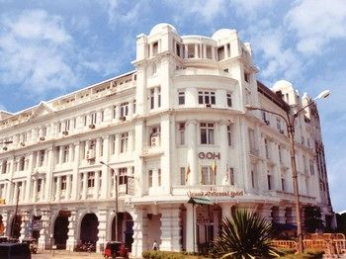
SIGHTSEEING

DAY-6
HOTELCHECK OUT

Stamford Staror Similar
Temple of Tooth
Kandy City Tour
Botanical Garden
Coco Royalor Similar
Drive to Yala Wild Life Sanctuary
Nuwara Eliya Tour
Haggala Garden
Victoria Park
Coco Royalor Similar
Yala Safari
Madhu River Ride
Turtle Hatchery
Grand Oriental Hotelor Similar
Colombo Dutch Museum
Beira Lake
Colombo City Tour
Town Hall
St. Lucia's Cathedral
Grand Oriental Hotelor Similar
Nuwara Eliya
From: DAY-2
Bentota
From: DAY-3 to DAY-4
Colombo
From: DAY-5 to DAY-6

